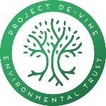

Project Director’s Report

Project De-Vine Environmental Trust

AGM 30th October 2024
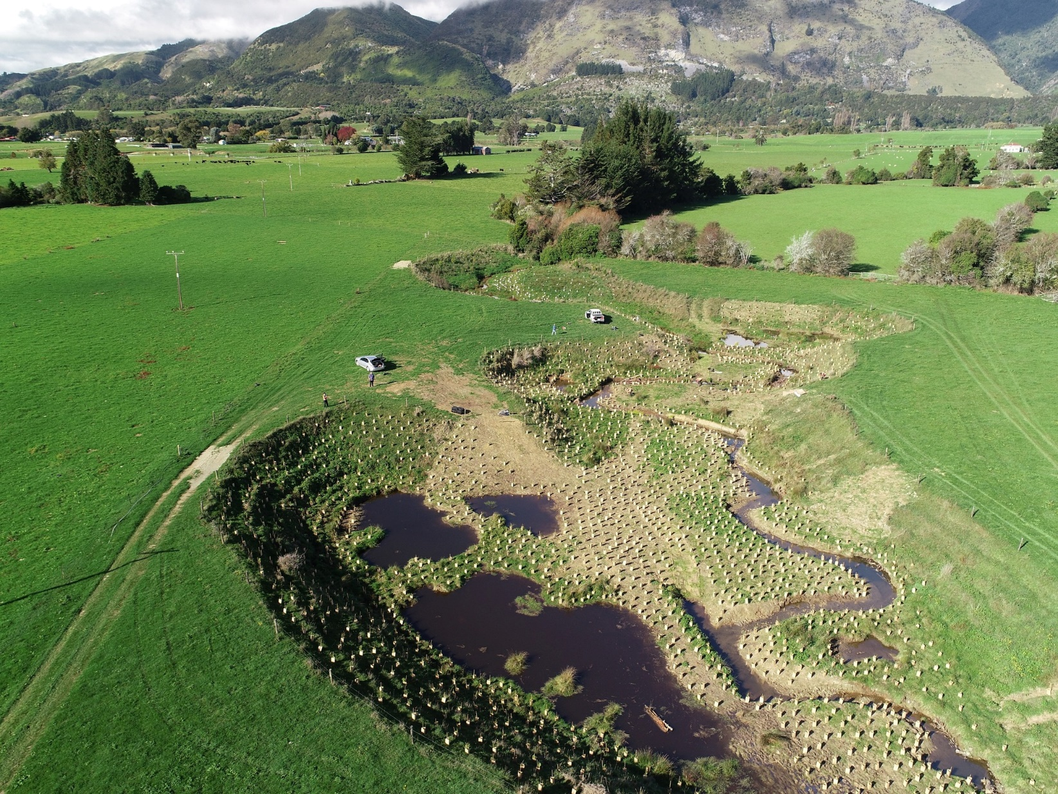
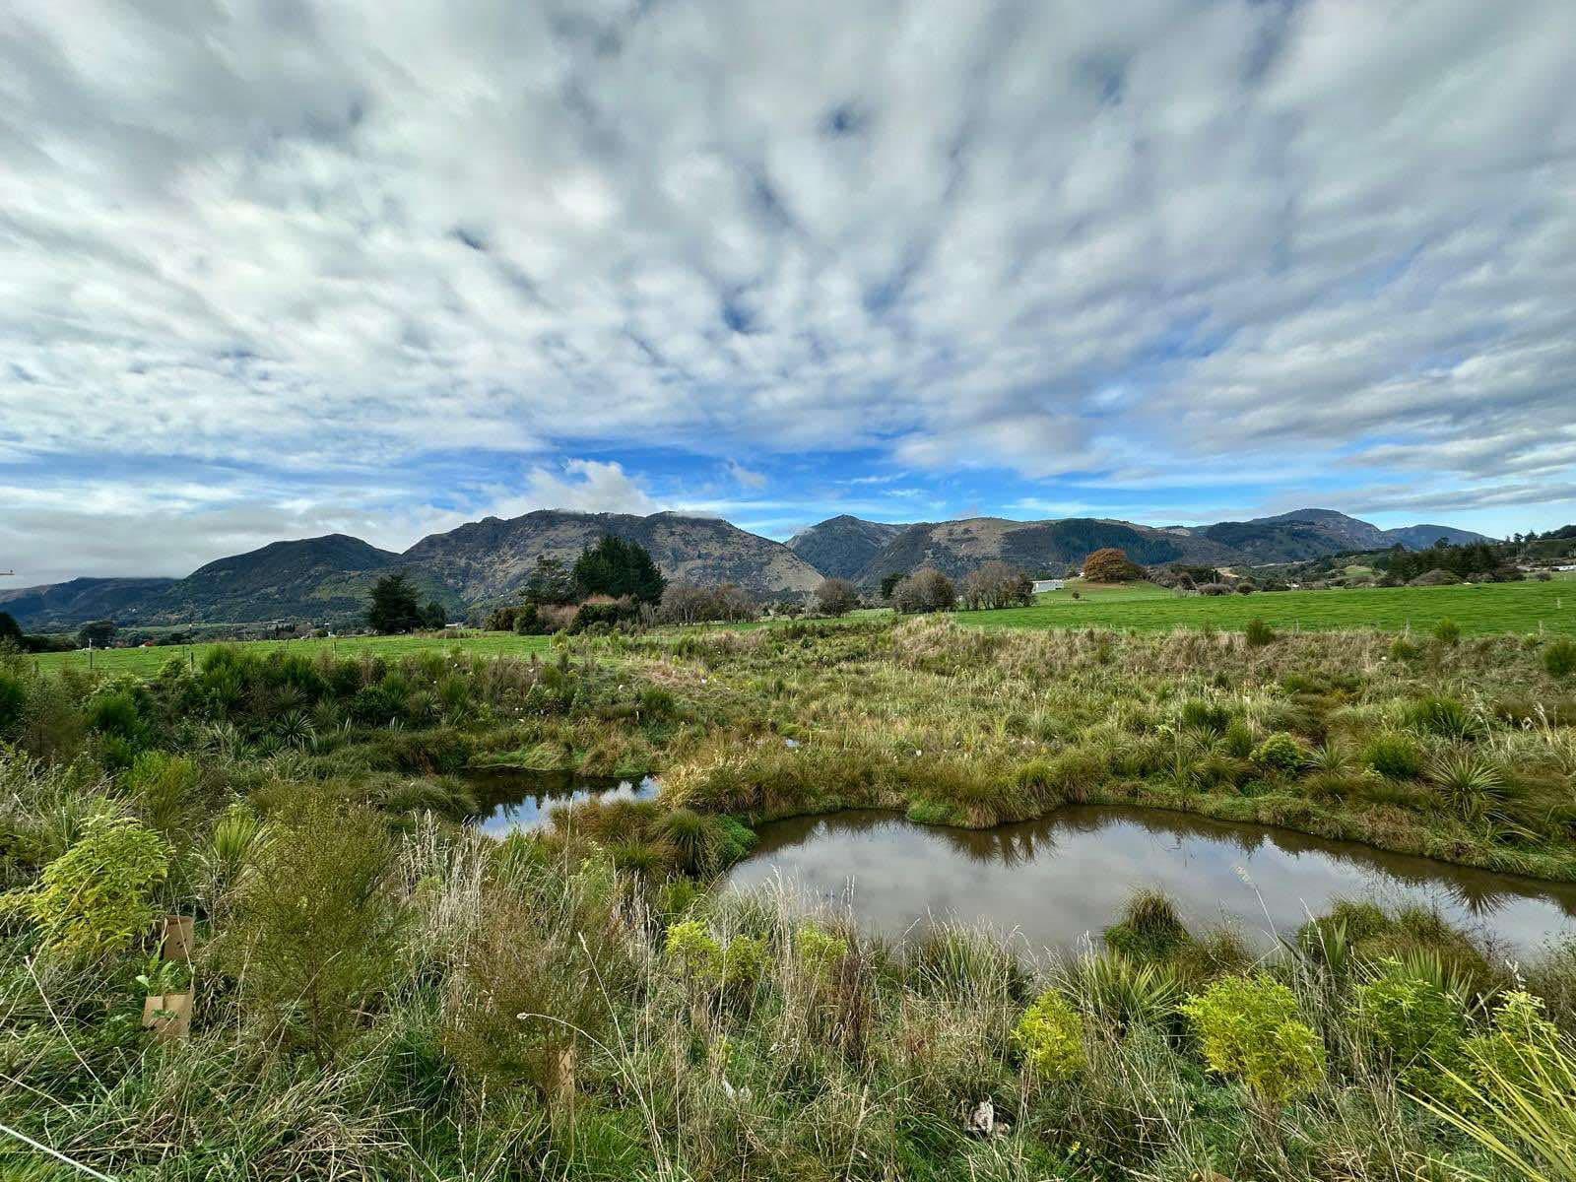
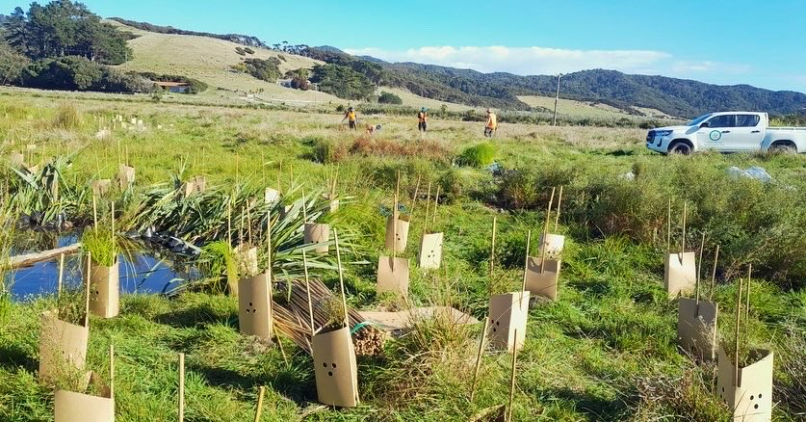

Funded Work Overview

The Trust has had yet another busy year with much of our time spent on the Jobs for Nature (JFN) contract and grant and planning for future work for our teams.
With the finishing of the JFN work we were employing 14 full-time field staff and 2.5 FTE office staff on 30th June 2024 (our end of the financial year). Our team leaders have been training up our remaining new staff in a range of eco-restoration skills. JFN was a game-changer towards achieving our goals of pest plant control throughout Golden Bay, as well as starting wilding pine control and a trapping network. We cover the details in the “contract” section below.
Small grants and other sources of revenue:
- We have continued with the pest plant and tree control work on Motupipi Sandspit that was started with a TET led Lotteries grant five years ago.
- We used a Cobb Mitigation Fund grant to assess the Upper Takaka area, MU-G2, for pest weeds and estimate the hours required to control them. This task will lead to a Lotteries grant application in early 2024 which unfortunately was declined.
- We were successful with small grants from TDC, the Sargood Bequest, and Golden Bay Community Trust.
- We failed with two grant applications to the WWF, Tasman Network Trust. As is now to be expected, the funders were massively oversubscribed.
- To try to keep up our momentum, we are now using our website as a site for giving donations to our various projects and looking for strategic partners. As the result of an article in the Golden Bay Weekly asking for donations towards establishing and managing a trapping network around the Motupipi Estuary, and Sandspit, and Golf Course we received $10,364.
- An unexpected option was given to us to take part in the dismantling of a Zero Invasive Predators (ZIP) trapping network in the Marlborough Sounds. We were chosen because ZIP wanted to support our plan to set up a trapping network around the Eastern Golden Bay section of Abel Tasman National Park, It was quite a logistical and physical challenge, but, 10 people in all ended up involved and over 900 traps and other devices were brought back by barge and then trucked from Picton to Takaka, A container was purchased and is housing them there. We have started selling them to landowners in the area and calculate that for the $5000+ spent in expenses they have a value to us of $30k+. A big thank you to ZIP and our staff, and the volunteers who took part.
- On a small scale we have started to take on setting up and managing trapping or bait station lines on two properties in Upper Takaka. With time this can expand now we have been through the costing of the tasks and other teething issues.

Our work continues to have a lasting impact on the environments in which we serve. As of 30/06/2024 our teams have manually killed 1,644,178 pest species in the Top of the South.
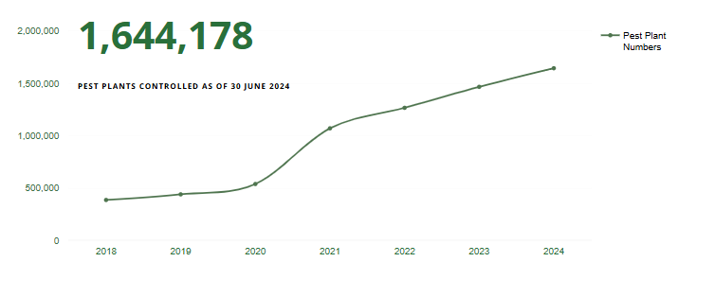The total number of vines & other pest species killed manually to 30/06/2024 is 1,644,178. This is an increase of over 136988k in the last year. The tally includes over 854,267 banana passion vines; 261,957 old man’s beard; 139701+ woolly nightshade; 16825+ climbing asparagus; and a mix of other species, including Taiwanese cherries (2235); sycamores (57520+); and pines (9167). A complete table of each species killed per year is now available annually on our website: Weeds Dashboard | Project De-Vine Environmental Trust.

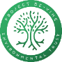
Contract Work
In 2024 Project De-Vine carried out an increased $ value of contracts. Our contracted work is part of our mission “Fostering Native Ecosystems in Golden Bay and the Top of the South.”

Value of our contracted work for 2024 was $894,136. Less the JFN boost of $595k = $299,136
Value of our contracted work for 2023 was $831.6k. Less the JFN boost of $595k = $236,583
Value of our contracted work for 2022 was $809.3k. Less the JFN boost of $595k = $214,367

2024 saw an increase in our contracted work, including our existing clients and TDC contract work. This includes plantings, weed control, and releasing of wetlands projects led by TDC with JFN funding.
June 2024 was the end of our 3-year Jobs for Nature contract to employ 9 FTE to carry out work throughout the Tasman District from Nelson Lakes, to Tapawera, to Golden Bay. We have visited some amazing sites during this contract, many with remnant forest.
Looking forward, we recently secured a significant contract planting and releasing job of nearly 13,000 plants in the Kingsland Forest for our Tasman team to start winter 2024.
In order to better deliver on contract work, we have restructured ourselves, starting with a website upgrade of our current work and data and this year an automation of our daily field data. This means that all the hours worked, species killed and other data per staff member and site do not need handling and our summated for wages, data analysis and other multiple uses. Our ArcGIS automated mapping system finally come online in August 2021, with staff using phones with dedicated apps to provide tracks, waypoints, comments and photos. There have been regular updates as well as using it in our wilding conifer and trapping programmes, each with a separate app. Our team leaders send in a “control sheet” daily detailing the work carried out and an “exit sheet” on completing the work at each property or job. We can analyse the data by property, management unit or per plant using multiple parameters.
The central and local government, and other agencies contributing to this contracted work encourage the many landowners to be more active on their own properties.

Other contract work in 2024 included:
- DOC repeat contract to control Tradescantia and Ivy in The Grove and Paines Ford Scenic Reserves.
- Kiwifruit Vine Health (KVH) contract to control kiwifruit vines at various sites in Golden Bay and the rest of Tasman.
- Our annual work with LINZ continues to control invasive weed species along the 11 rivers of Golden Bay for which they have riverbank responsibility.
- Increasing contributions from landowners also feature as we are using a co-sharing arrangement with the Rata Foundation grant and the landowners for areas where we do not have large-scale funding.

Grants Completed or nearing completion
The following grants, approved before 1st July 2023, were finished off in the 2024 year, or delayed to the next year (All figures are GST exclusive).

- MU-G2 – Assessment of pest weeds for control.
Funded by: Cobb Mitigation Fund
This involved assessing 50 properties in the Upper Takaka valley for invasive plant and tree species. Although we failed with the Lotteries funding application, we can use the data and secured funding to try other funders.
Colour code | Number of properties >1200m2 in the upper Takaka valley - MU-G2 | Hectares | % of the land area
Total number in MU-G2 | 58 | 7256.71
No permission - assessed from boundary | 1 Has weeds present See assessed column | 57.86 | <1.0%
Total NOT assessed to date | 8 | 649.4499688 | 8.90%
Total assessed | 50
Assessed Clear of pest vines, wilding pines and other pest species (ochre fill colour + self-managed DOC lands in blue) | 17 | 1730.233087 | 23.80%
Assessed with pest species (green fill colour) | 33 | 4877.031084 | 67.20% | 41.44% with high priority weeds. 25.76% with lower priority weeds
2x TDC titles & 1x LINZ title | 3 | 3.9
DOC titles | 6 | 1296.8

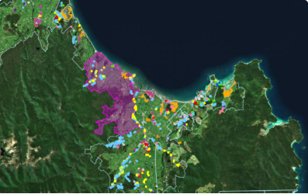 | - MU-C1 – Takaka River to Onekaka  Funded by: DOC Community Fund  Controlling of the only outlying site outside of the Takaka valley of yellow jasmine and working to stop the spread of the other RPMP plants in the management unit between the Takaka River and Onekaka: BPV, WNS and OMB. Finishing in November 2024.
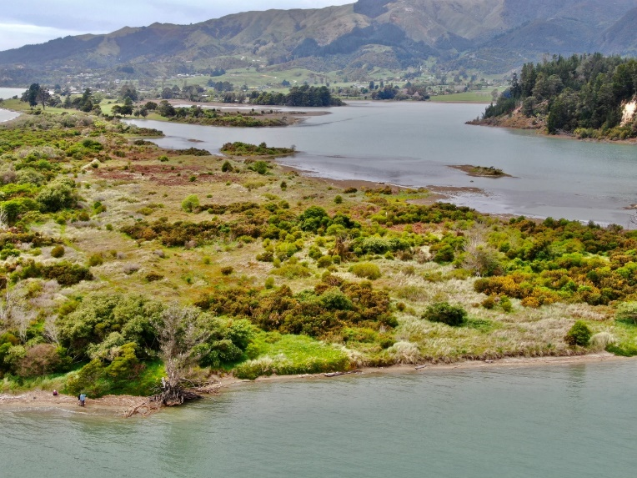 | - MU-6 – Motupipi Sandspit weed control  Funded by: Tasman Network Trust.  The aim of this grant was to continue our follow up control seedling pines, sycamores and pest weeds.
- Rata Foundation grant:
This was used to co-share ongoing weed control work on multiple mainly larger properties and farms in the Takaka Valley.

Grants Received
We have received 14 grants / sponsorship / and multiple donations in this last financial year 2024 - valued $96,984 plus 1/3rd of the JFNCCF grant of $700k:

- Jobs for Nature Community Conservation Fund for Multiple projects in Golden Bay to employ 3.5 FTE - $233,333 for each year.
- Rata Foundation 2021 three-year grant for a split of “Follow up control work” in Golden Bay & Operating costs - $120,000 with $40k available each year. This year it was solely used for field work together with landowner contributions to keep sweeping the weediest sites from Takaka to Wainui.
- Tasman District Council grant for Operating costs - $36,120
- Sargood Bequest $3000 to assist with our East Mohua Trapping Collective costs.
- Golden Bay Community Trust grant: $2000 to continue the exotic tree and pest plant control at Motupipi Sandspit.
- Multiple donors$10364 to support Motupipi Trapping Network
- TDC $1500 to support us running a trapping hui in Sept 2023
- NBS Takaka for gel bottles to landowners in their area – $1000 each of the branches has maintained its sponsorship to allow for the increased numbers of properties getting involved in their “swap a bottle” scheme for gel bottles to cut and paste pest plants. See appendix of how some of the gel bottles were used.
- NBS Motueka for working bee & gel bottles to landowners in their area – $1000.
- NBS Richmond for gel bottles to landowners in their area – $1000
- NBS Nelson for gel bottles to landowners in their area – $1000
- Cut 'n Paste Ltd. Ongoing: 25% discount on all products. Our supplier of Gel for cut and paste work.
- PGG Wrightson: Ongoing: significant discount on all products
- ITM: Free materials to build 40 more stoat and rat traps

Grants in Action  This year’s grants, with our sponsors, enabled us to continue the Trust’s landscape-scale pest predator, plant, and tree control.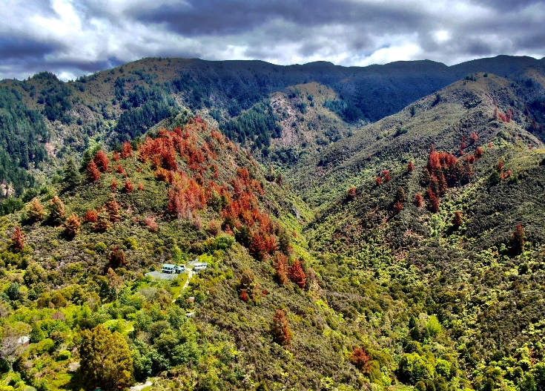  Figure 1. Craigieburn with KNP Boundary  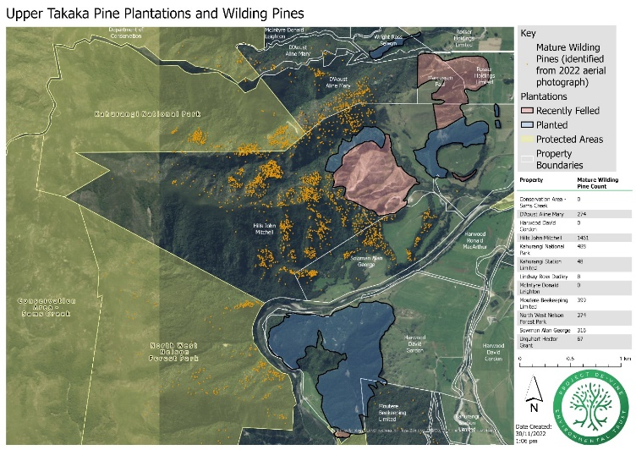  Figure 2 Upper Takaka Wilding Pines  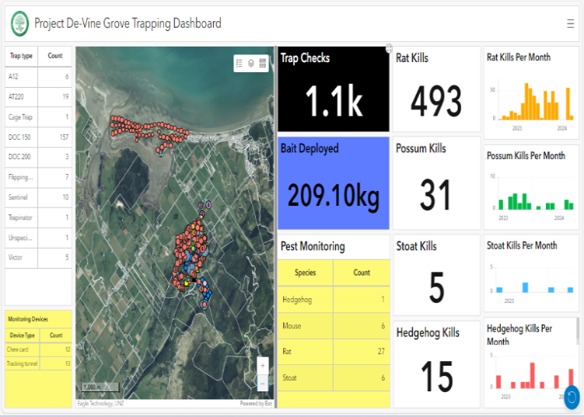  Figure 3 Trapping Dashboard of Kills to Date |  | JFN Grant | $233,333.00  Jobs for Nature Community Conservation Fund (JFNCCF) for Multiple projects in Golden Bay to employ 3.5 FTE over three years - $700,000.  - Carry out pest plant control in MU-C2 and MU-B for the first time on a large scale. Completed third year sweep from Onekaka to Pakawau  - Carry out follow up pest plant control work in MU-D5 to D3 – Wainui to Pohara on a large scale with enough funding to complete sweeps of all the large properties that have eluded us up to now, as well as follow up work on some of the other properties. Completed third year with a sweep of the key remaining large weedy properties.  - Carry out wilding pine control on a significant scale on key properties – with the survey completed by satellite – between Tukurua and Wainui. We have done work in East Takaka to Clifton and Craigieburn. To date 2500 hours have been completed to clear 4400 wilding confers over 1600has. (Figure 1,2)  - With the loss of the Wilding Pines Community Partnership Projects funding, we will be approaching forestry companies to be strategic partners in helping to clear more blocks of conifers.  - Set up, monitor, & maintain a pest mammal trapping programme in the Grove Scenic Reserve and the immediate adjoining ten properties over three years. This is now completed with a mix of manual and self-setting traps, and bait stations. See the dashboard of our trapping kills to date. (Figure 3)
TDC Grant | $36,120  From TDC, we received $36,120 towards operating costs as an annual grant for each year in their long-term plan. |  | With the extra work to cover the JFN contract and grant, as well as other significant contracts, our office staffing has increased. With my involvement to create the new programmes of trapping, wilding pine control, funding applications and their final reports I am still busy!

Behind the Scenes
We've revamped our operations with a website upgrade and the integration of ArcGIS mapping, enhancing our efficiency in wilding conifer control and trapping. The Trust continues to use primarily chemicals without the reputedly toxic surfactant polyethoxylated tallowamine, or POEA, instead using the cosmetic grade safe surfactants, containing alkyl polyglycosides (APG) which is derived from sugars or fatty alcohols, or more recently Alkyl DiMethyl Betaine (ADMB).
The Trust maintains a high level of reporting to funders, and maintains its approved contractor status with TDC, DOC, NZTA, LINZ and QEII. Its Health and Safety Manual is updated annually, and an external audit was completed in Aug 2023.

Behind the scenes  Presentations about our work are given annually or to suit: | - TDC Biosecurity department and the TDC Biodiversity Forum; Golden Bay Community Board; Nelson Marlborough Conservation Board  - Local DOC staff and local (Golden Bay and Motueka) iwi updates are provided annually.  - Commissioner for the Environment weed report was released in Nov 2021 and has spawned the formation of the Environmental Weed Coalition. It meets monthly by zoom and I have been presenting twice in this year.  - TDC BioStrategy Nov 2021 Consultation Final with ongoing engagement. This is part of a national strategy and hopefully will lead to more action in the region.  - Presentation to U3A in Takaka  - Presentation to Hui re the East Mohua Trapping Collective Sept 2023.  - Submitted Presentations at the NETS conference in Invercargill July 2024

The Trust has three reporting methods in action:
- Plant counts by our field teams  - Ongoing Seedling count  A seedling count on four properties in Clifton which is now in its 15th year.  The graph attached shows the residual reseeding to 30 June 2024 with 11,298 killed to date. This shows how easily a few missed vines can produce copious seedlings. | See reported above.
- Phase Reporting System
The Trust has developed a reporting system based on the 4 phases of weed control and analysis of all the properties. See appendix for the full graphs.

This has so far been applied to our work in:
MU-D4 and D5 – completed and to be updated when the JFN grant finishes next June.
- MU-D6 -- see attached MU-D6 graphs of before and after.
- MU-H – completed.
MU-E & G1; MU-C1 – both nearly completed

Looking Forward
The Trust aims to maintain a state of zero-density for invasive environmental weeds and wilding conifers across Golden Bay, contingent upon funding.
Also, it is expanding the trapping network it initiated in the Grove Reserve and now includes the Motupipi Estuary, Sandspit and Golf Course to create a broader predator-free halo population of Abel Tasman National Park. This was renamed the East Mohua Trapping Collective to reflect the many landowners and groups inside the area whom we are working with. This is in collaboration with stakeholders like the Friends of East Mohua (FOEM), and receives support from Project Janszoon, sponsors and donations. We have applied to receive support from Kotahitanga mō te Taiao (KMTT) the Top of the South Alliance of Councils, DOC and iwi. Once this is approved, we will seek funding for a trapping network in Wainui and expand efforts in other areas as resources permit. This will provide ATNP with a low predator halo population to help the bird populations thrive there and expand into the rest of Golden Bay. In time this can be expanded, as funding and volunteers allow, to connect with other trapping networks, like the Forest and Bird coastal network and others. See map of the overall trapping area, EMTC and the five different areas making up the trapping network.47. map of the five areas of the overall trapping network area
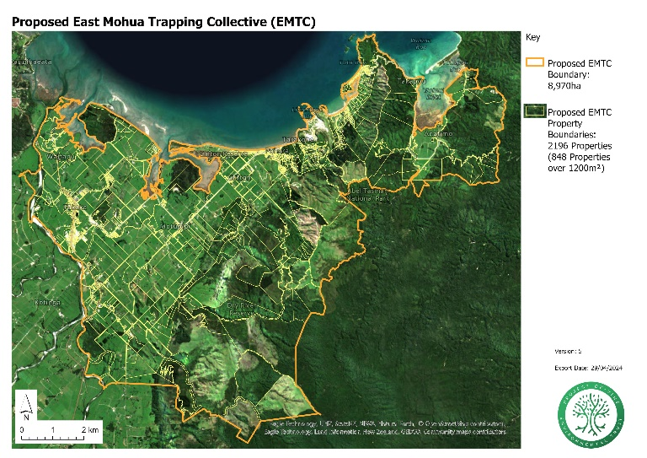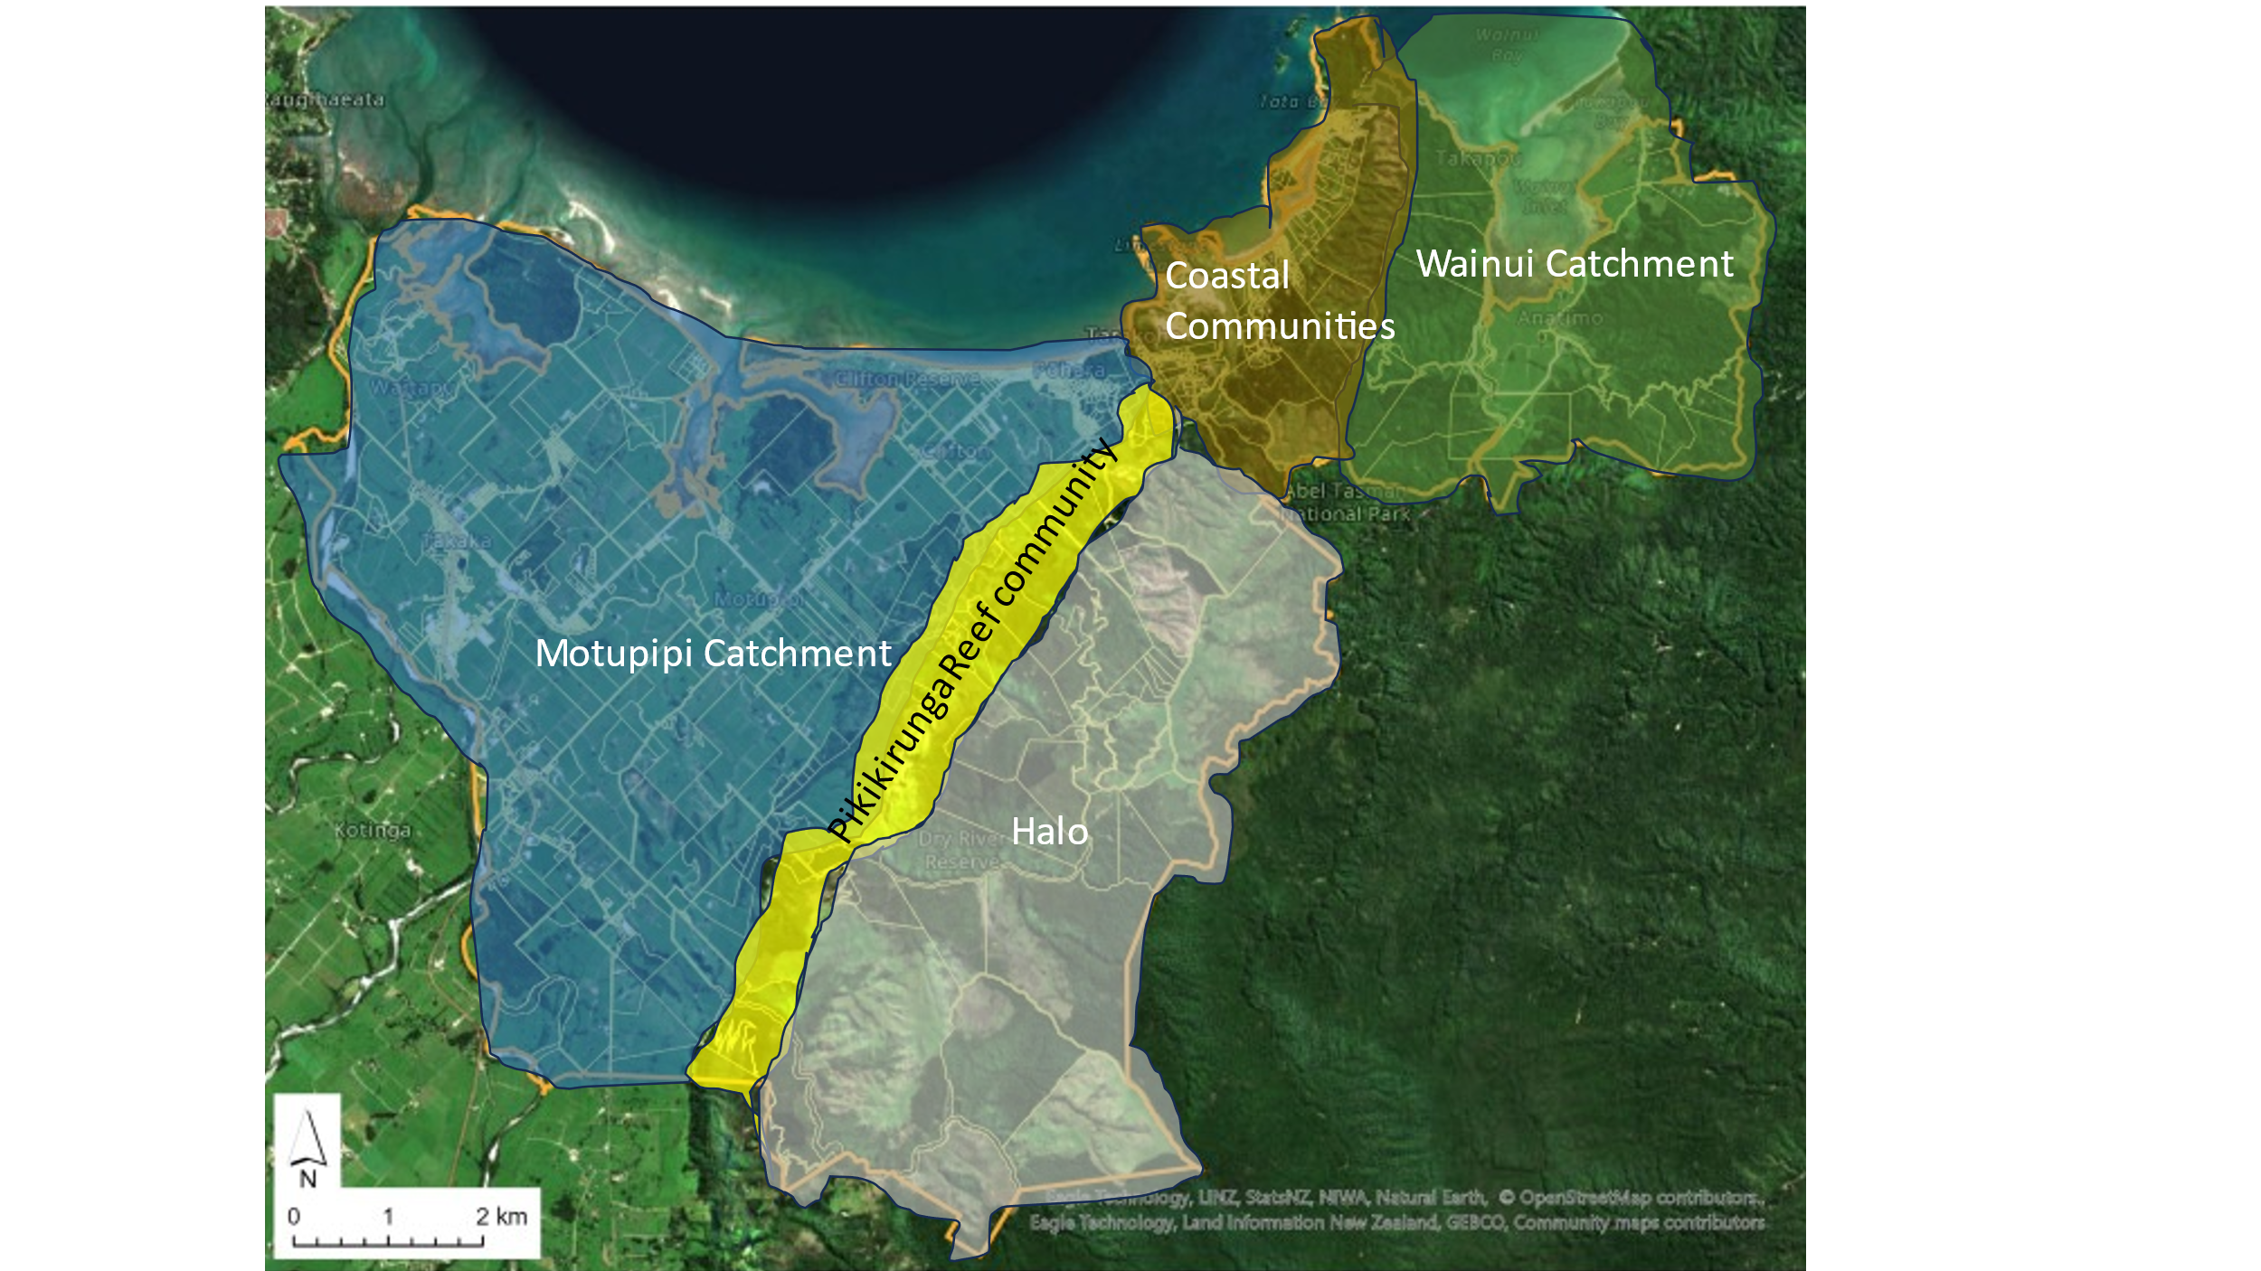

Wilding Conifers  Golden Bay wide plan for controlling Wilding Conifers  With aerial analysis completed the trust will continue to apply for funding to protect our national parks from wilding pine infestations. Our teams on the ground have already started control on properties around the Halo of the park and this work will continue subject to funding. | Ongoing weed control  Continuing our mission for zero density invasive weeds.  The Trust has a Golden Bay wide plan for controlling environmental weeds and will continue to try and maintain a state of zero-density for the most invasive ones – subject to funding of course.
A Big Thank You
Thank you to our trustees, staff, and many others for your support & advice on this journey of pest species control which paves the way for enhanced environmental restoration in Golden Bay & the “haloes” of our adjoining National Parks.

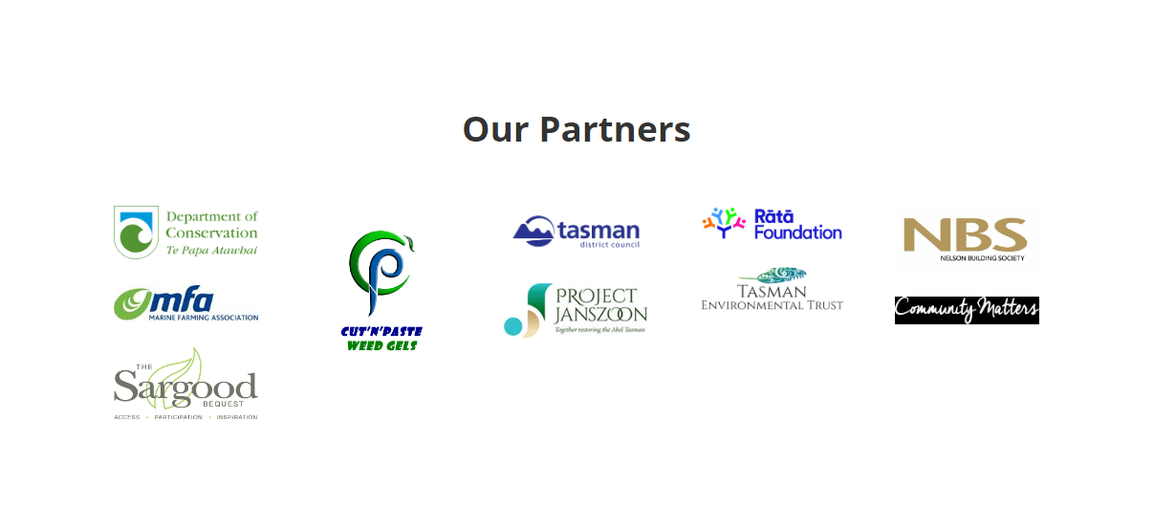
A big thank you to our sponsors:

- Cut’n’Paste who give us a generous discount on their gel products.
- PPG Wrightson for a generous discount and ITM for free materials to make traps.
- Golden Bay Weekly, who publish our monthly tally of vines & other pest species, killed manually.
- Nelson Building Society – Takaka, Richmond, Nelson and Motueka branches - who assist with giving out free gel bottles.
- Annette Litherland at Landcare Trust has been a great resource to help make projects happen.
- Tasman Environmental Trust – our partnership with the Motupipi River project has been a great way for a true team effort. Their support via the Cobb Mitigation Fund, particularly for our projects to work our way up the Takaka Valley in three stages, is creating amazing outcomes.


Chris Rowse
Project Director for Project De-Vine Environmental Trust

Appendix

- Management Unit map
- Photos of a/OMB site high up in the Rameka Gorge and b/ Dead vines there
- Photo showing dead pines and map of pines in Craigieburn with KNP boundary
- See the dashboard of our trapping kills to date at the Grove Reserve and environs
- The graph attached shows the residual reseeding to 30 June 2023 with 10,859 killed to date.
- MU-D6 summary tables and graphs of before and after
- Map of the five areas of the overall trapping network area
- Proposed East Mohua Trapping Collective map
- NBS & Cut'n'Paste Ltd sponsorship of gel bottles report for 2023 to 2024

- Management Unit map
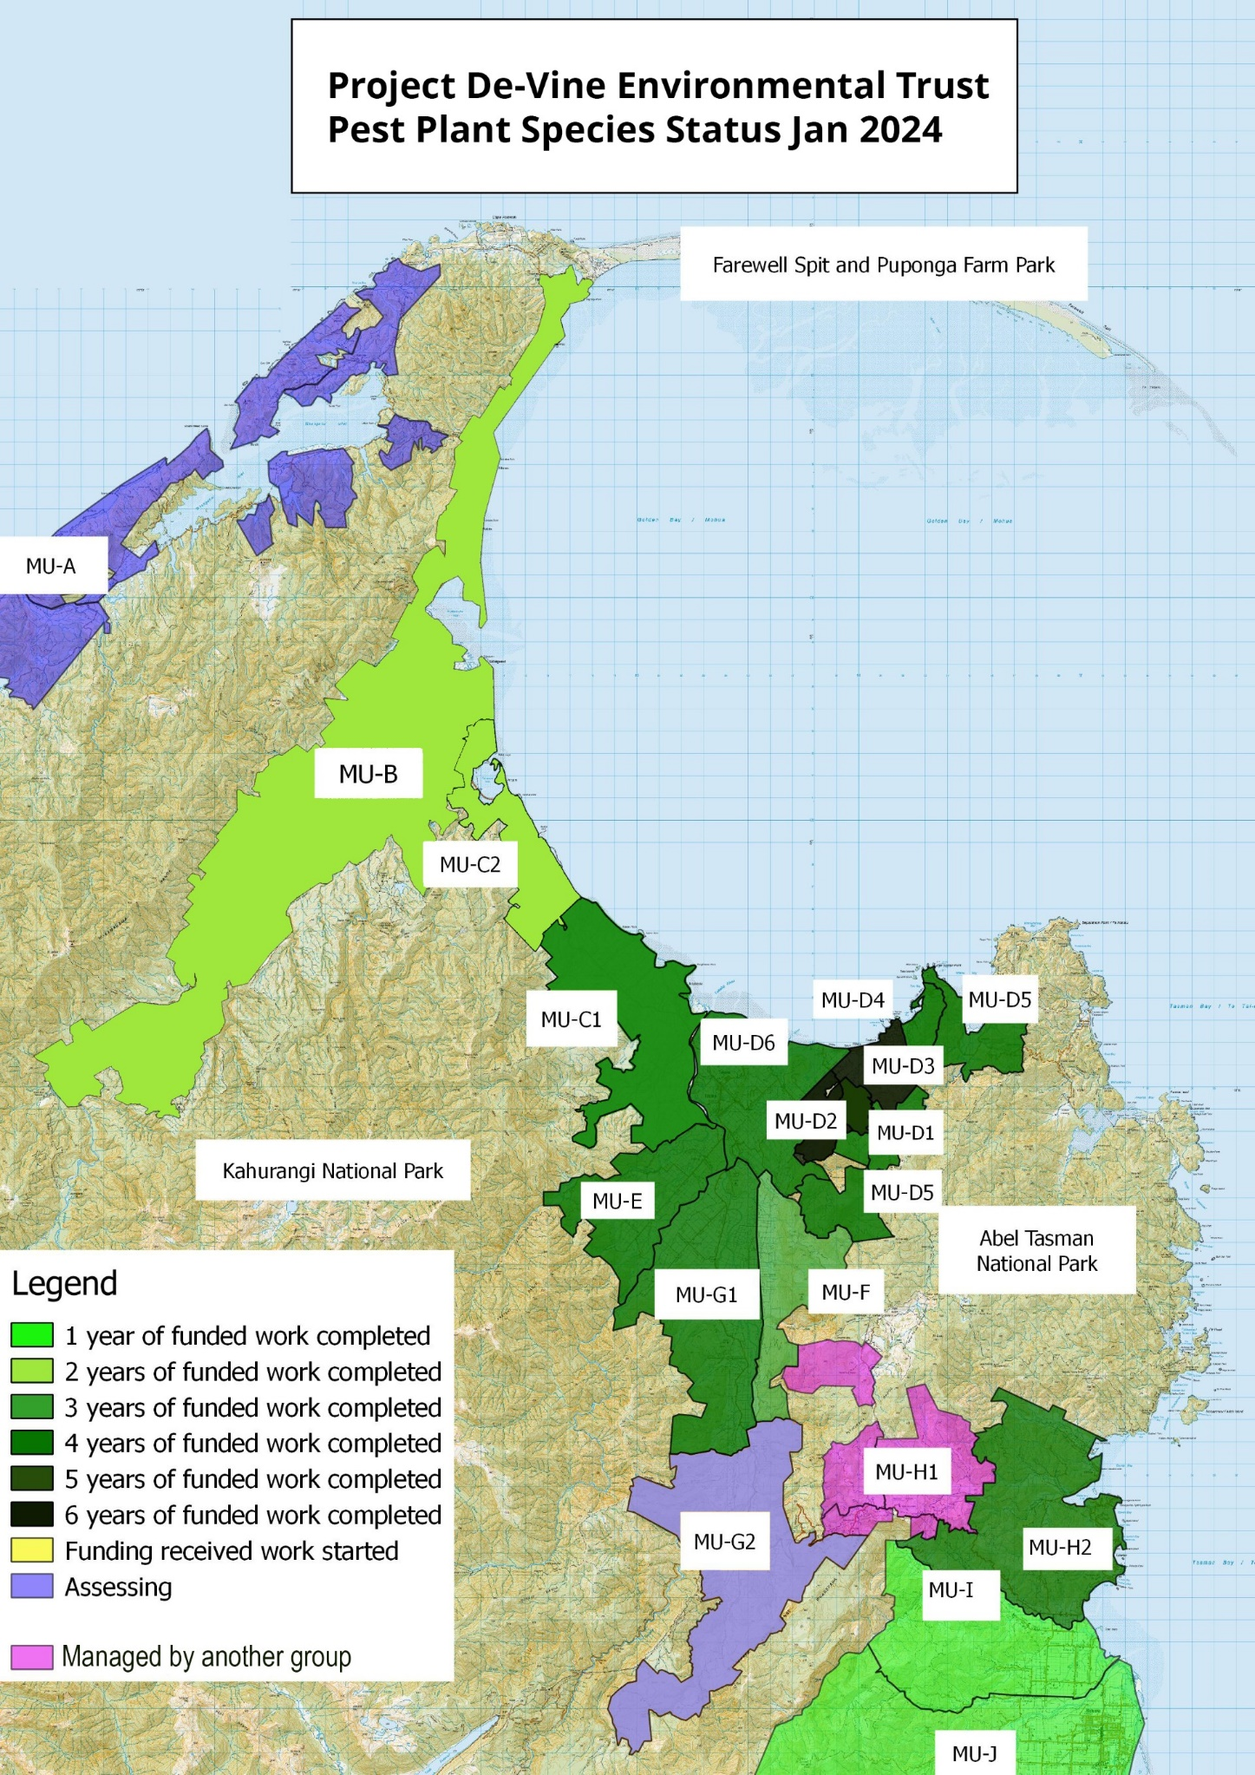

- Photos of a/ OMB site high up in the Rameka Gorge and b/ Dead vines there 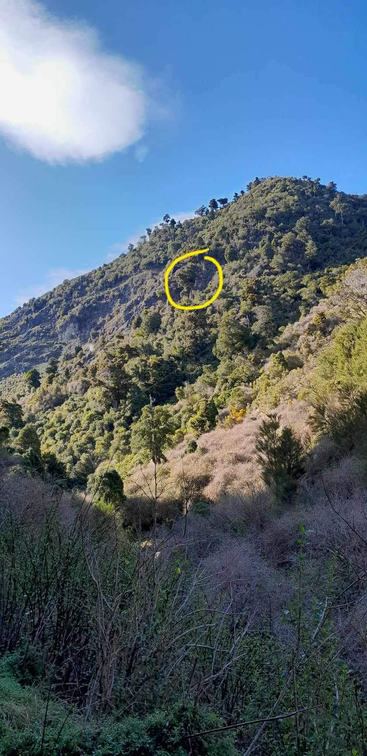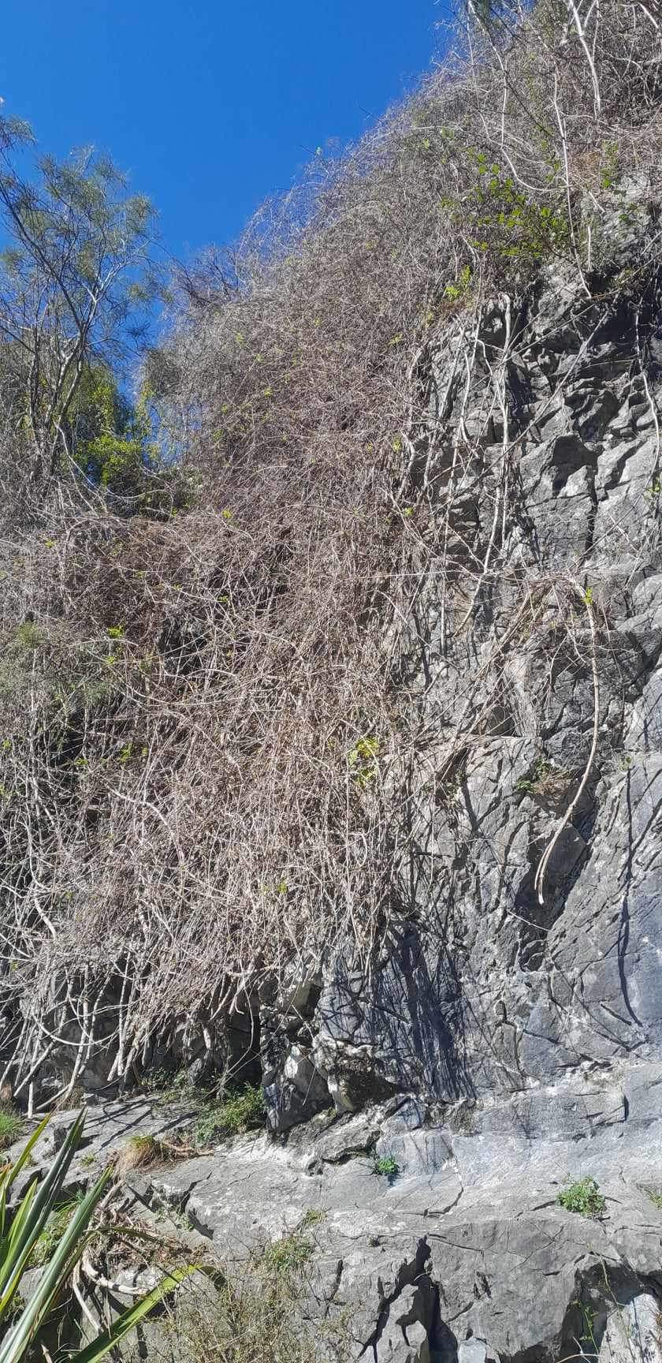

- Photo showing dead pines and map of pines in Craigieburn with KNP boundary
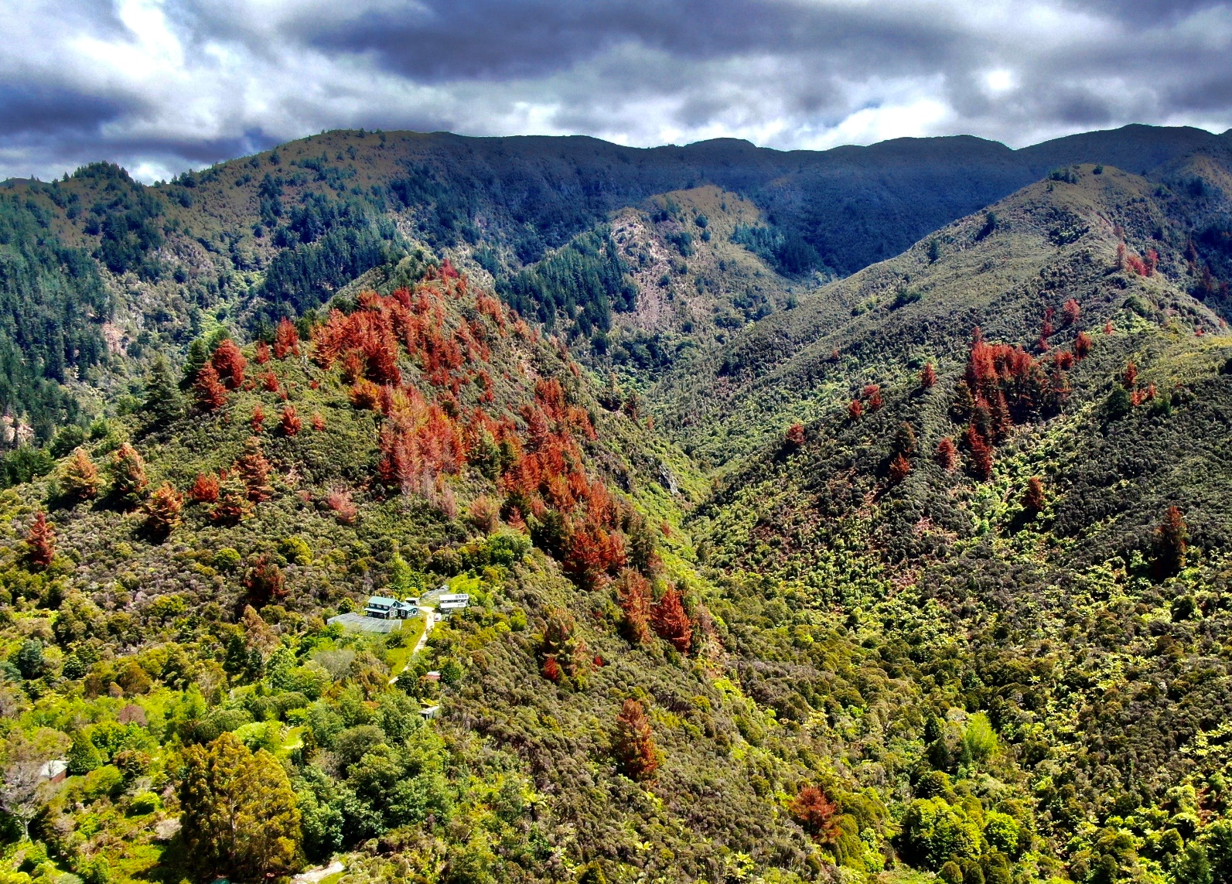

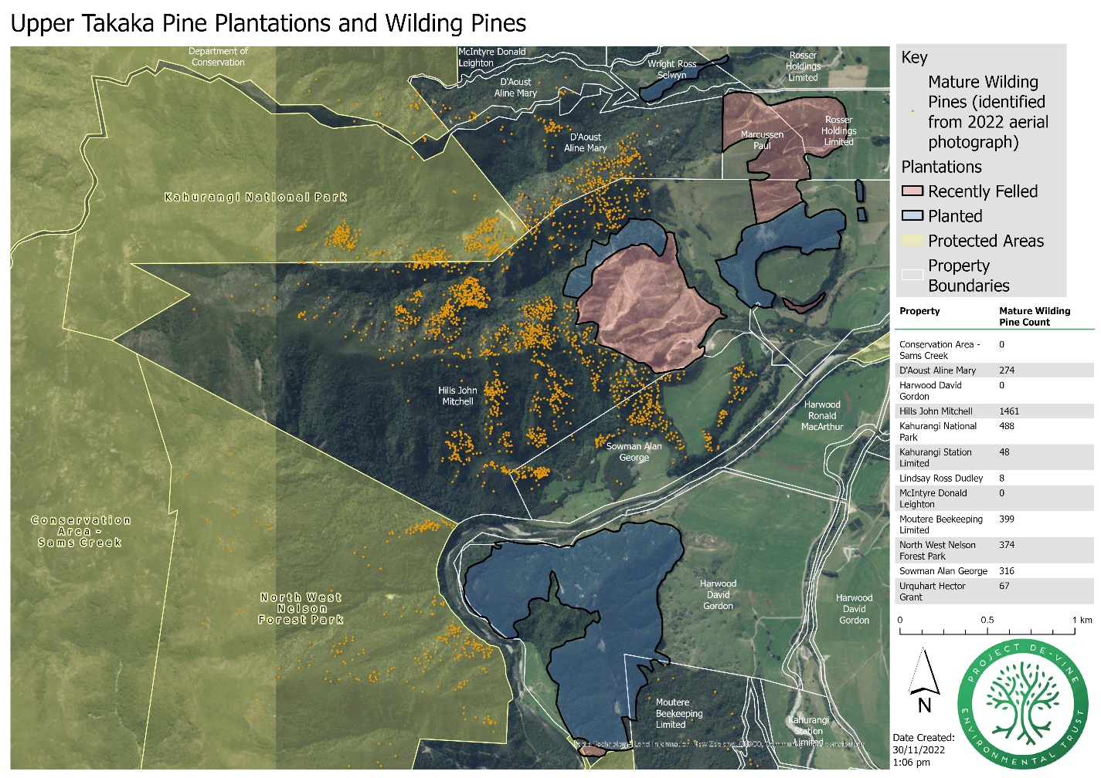

- See the dashboard of our trapping kills to date, 22 Oct 2024, at the Grove Reserve, Motupipi Estuary and environs
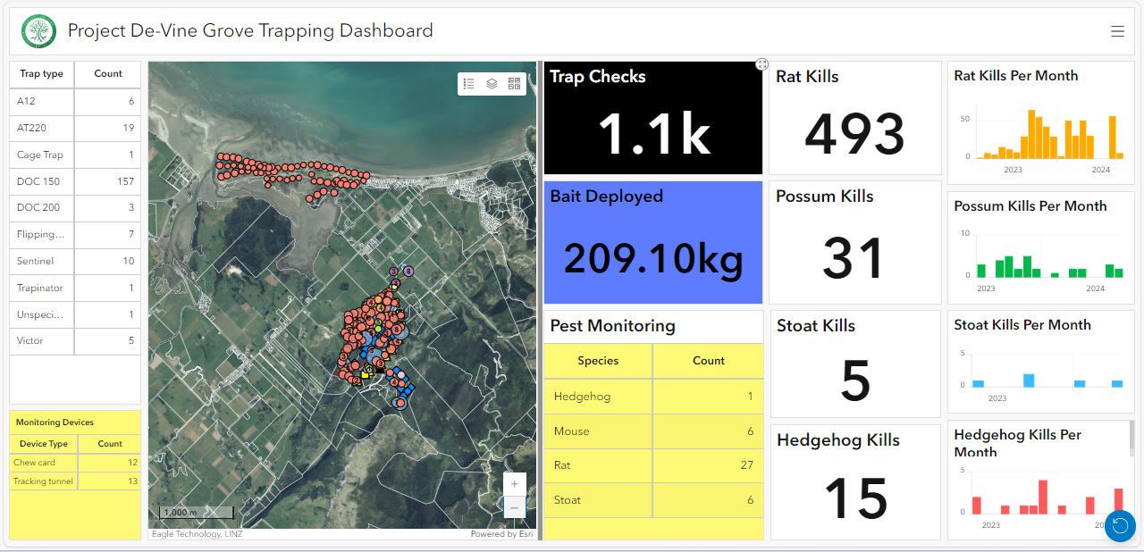

- The graph shows the residual reseeding on four properties over 14 years to 30 June 2024 with 11,298 killed to date.

2011 | CR logs big exotics in gully
2015 | GW cuts down yellow jasmine under cliff
2014 to 2016 | Neighbour (Pessione) stop control and have lots of mature BPVs
2017 onwards | Regular neighbour (Pessione) BPV control resumes
2021 | DF lots of seedlings when opening up wild area
2022 | CR finds 3 Mature BPVs uphill in light wells from dying gorse
2023 | CR has many Seedling BPVs up hill

- MU-D6 summary tables and graphs of before and after

START- MU-D6 Lower Takaka areas under varying control involving properties of >1200m2
 |  | Number of properties. They can be listed in more than one row | Hectares | % of Total area | Comments
Area receiving control work | Controlled | 0 | 0 | 0.0%
Area assumed or known to be clear | Clear | 359 | 672.43 | 16.8%
Area still to be controlled – subject to funding limits with permission | Still to control | 70 | 3018.3438 | 75.4%
Area still to be controlled with no permission from landowner | No permission | 7 | 310.518 | 7.8%
Total area in MU (all properties of >1200m2) |  | 437 | 4001.2918 | 100%
FINISH- MU-D6 Lower Takaka areas under varying control involving properties of >1200m2
 |  | Number of properties. They can be listed in more than one row | Hectares | % of Total area | Comments
Area receiving control work | Controlled | 46 | 2560.6060 | 66.9%
Area assumed or known to be clear | Clear | 359 | 672.4300 | 17.6%
Area still to be controlled – subject to funding limits with permission | Still to control | 25 | 457.7380 | 12.0%
Area still to be controlled with no permission from landowner | No permission | 3 | 135.0000 | 3.5%
Total area in MU (all properties of >1200m2) |  | 437 | 3825.7740 | 100%

- Map of the five areas of the overall trapping network area

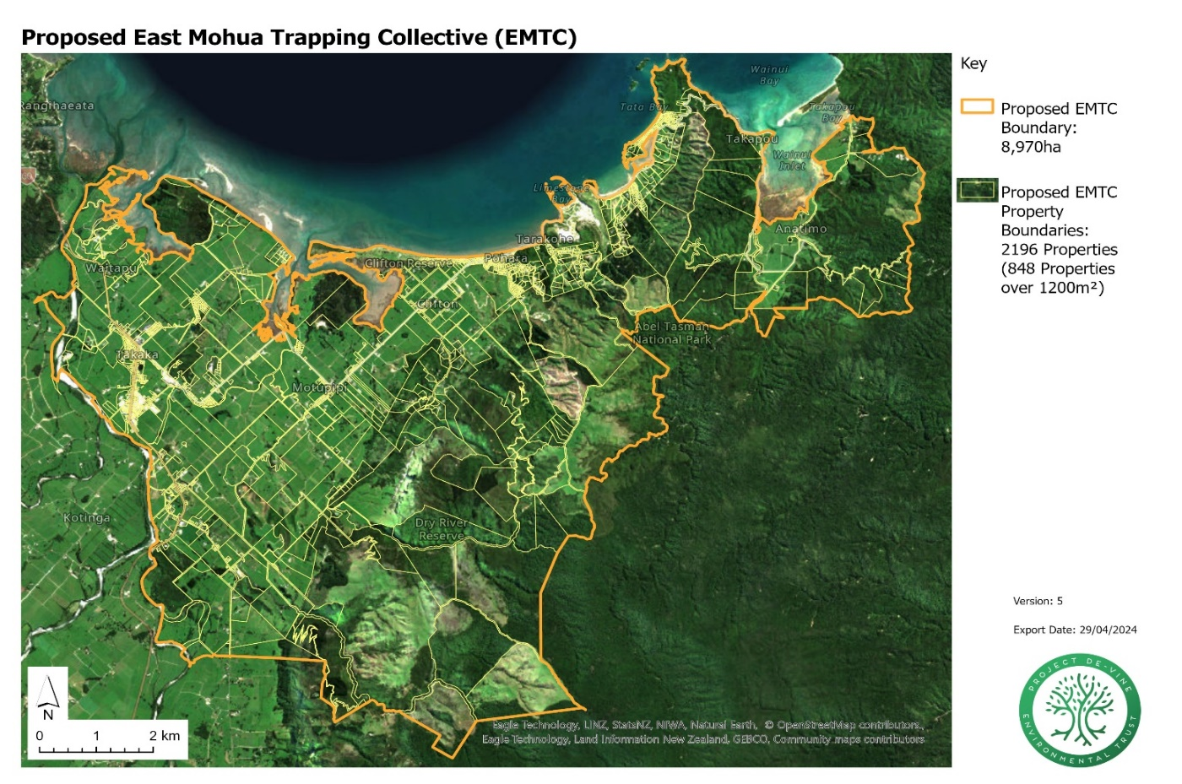
- Proposed East Mohua Trapping Collective map

- Sponsorship report for the year to June 2024
NBS sponsorship of free glyphosate gel bottles throughout Tasman
Co-sponsored by Cut’n’Paste Ltd who give us a discount on the supply price.
These are given out to landowners and small groups so they can cut and paste invasive vines and other pest plant and tree species. Refills are also available.
Around the district:
Golden Bay:
- One landowner in the Kotinga valley who has been working on invasive vines for many years with the glyphosate gel bottles commented how useful they have been to control hundreds of Taiwanese Cherry seedlings which had sprouted from a neighbouring source.
- A keen group of six local residents in Ligar Bay meet regularly to walk the bush area at the back of the housing there. They noticed many old man’s beard seedlings and with a suggestion from a friend contacted Project De-Vine for gel bottles. They carry the bottles and a cutting device with them on their walks to deal with them and have added in other pest plants to their list to cut and paste as they find them.
Richmond:
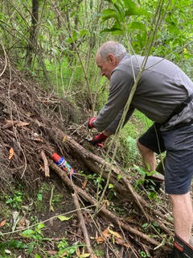
- Dave Phillipps from the Roding River Catchment Enhancement Group was very happy to get his bottle of Cut & Paste supplied by TDC and funded through Nelson Building Society. The Group are using Cut & Paste tubes to control Old Man’s Beard, Hawthorn, Barberry and other noxious weeds along the riparian margins of the Roding River. The Catchment Group is working on the stretch from the Hackett Reserve all the way down to TDC’s Busch Reserve both on private land and helping improve the Council Reserves. Further down the track they hope to expand both up and down the river with their work. They have already started planting natives on the riverbanks and have plans for much bigger areas in the 2025 planting season. There are also revegetation projects away from the river on land recently harvested from pines and retiring areas of pasture to native plants. Enhancing native birdlife by controlling pests is also a big goal for the Catchment Group.
  - Dave Phillipps, Roding River Catchment Enhancement Group member cutting and pasting Old Man’s Beard by the Roding River.
- Aniseed Valley residents and our local Hope school have a history of working bees in the TDC reserves and over the years have planted many of the big established natives you now find in Busch and Twin Bridges reserves.
Motueka:
- Mixed landowners throughout the area including up the Motueka Valley where various weedbusting groups are active.
Thank you for your ongoing support it is gratefully received and helps us to be more successful in our work with hundreds of landowners.
The Project De-Vine Environmental Trust team

